**Ideation Phase**

**Brainstorm & Idea Prioritization Template**

|  |  |
| --- | --- |
| Date | 03.09.2025 |
| Team ID | NM2025TMID08924 |
| Project Name | Citizen AI – Intelligent Citizen Engagement Platform |
| Maximum Marks | 4 Marks |

**Brainstorm & Idea Prioritization Template:**

*Citizen Al Intelligent Citizen Engagement Platform: Idea Generation & Prioritization Just as traditional brainstorming fosters an open environment for creative problem-solving, a Citizen Al Intelligent Citizen Engagement Platform provides a dynamic space where every citizen can actively participate in shaping their community. This platform encourages the free flow of ideas, prioritizing the volume of diverse input over initial perceived value. Out-of-the-box suggestions are welcomed and, through the power of Al, can be built upon and refined. The platform facilitates collaboration, allowing citizens and Al to work together to develop a rich array of creative solutions for civic challenges.*

**Step-1: Team Gathering, Collaboration and Select the Problem Statement**

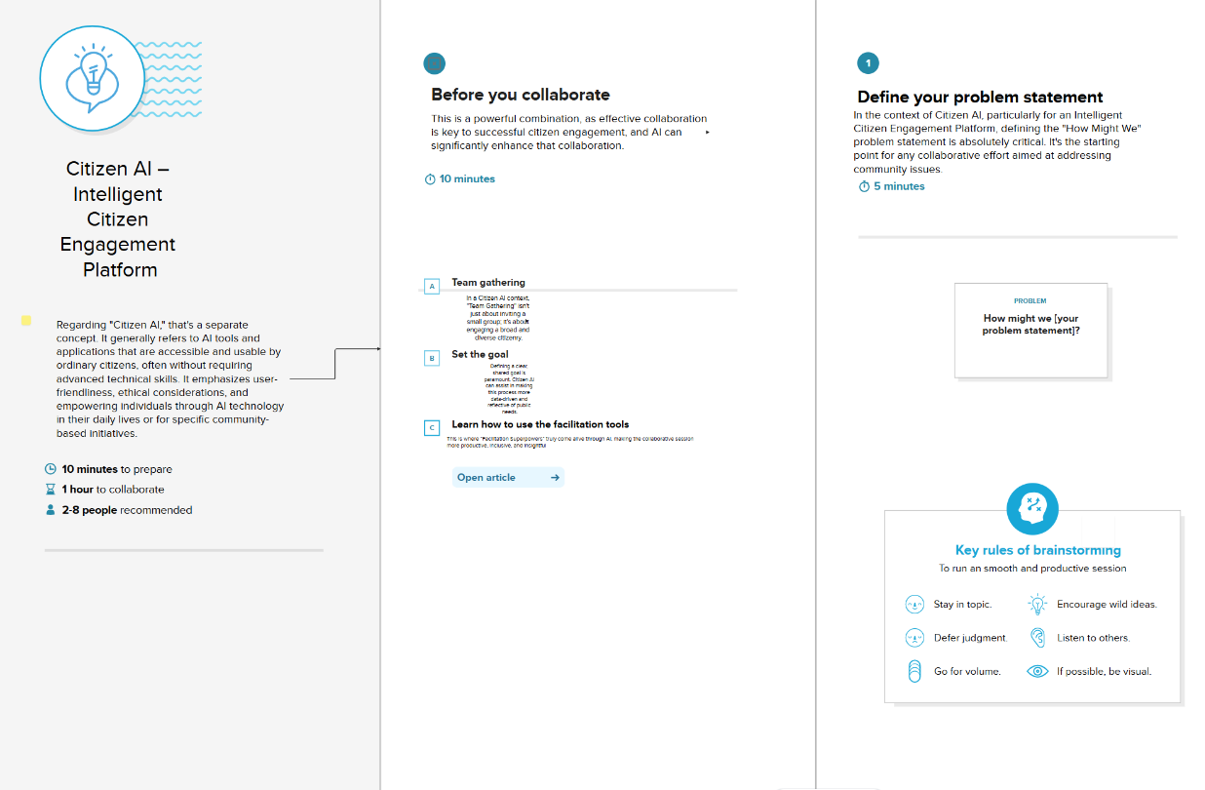

**Step-2: Brainstorm, Idea Listing and Grouping**

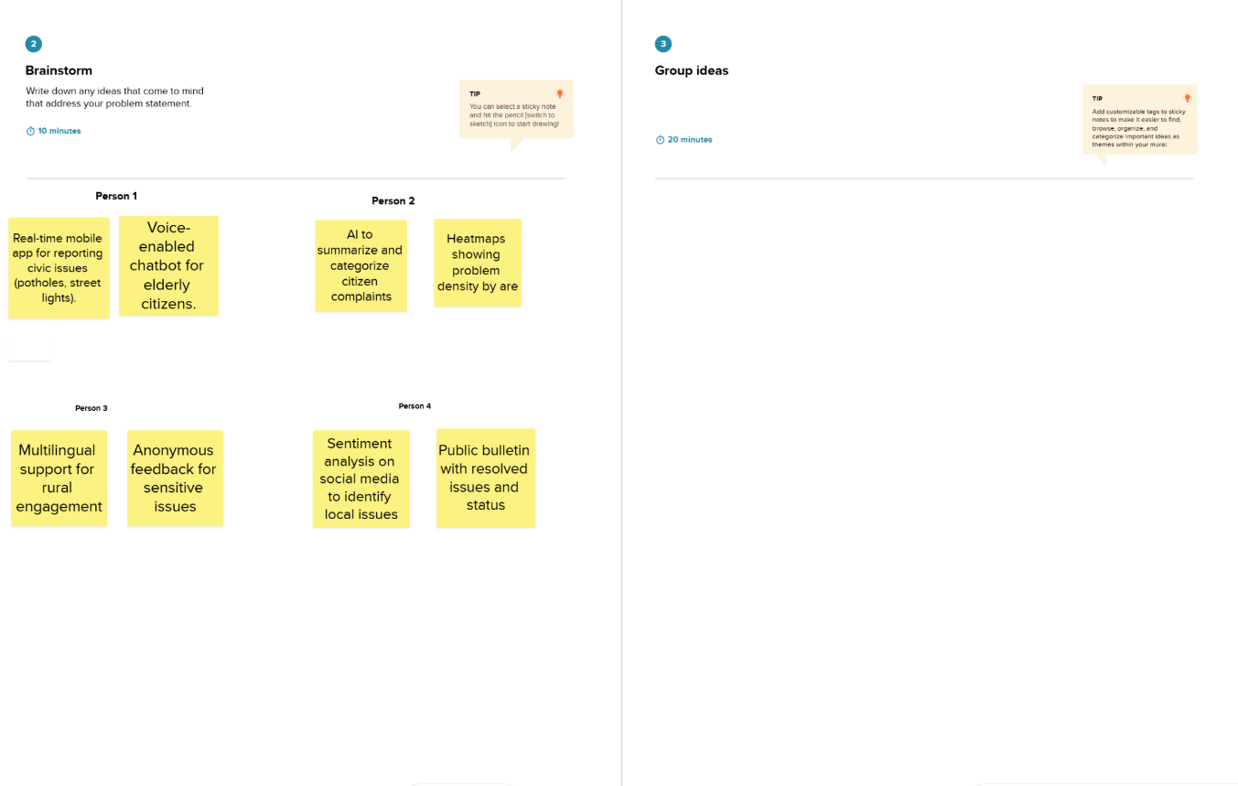

**Step-3: Idea Prioritization**

